ANSIBLE FACTS :



Ansible facts are data gathered about target nodes (host nodes to be configured) and returned back to controller nodes. Ansible facts are stored in JSON format and are used to make important decisions about tasks based on their statistics.

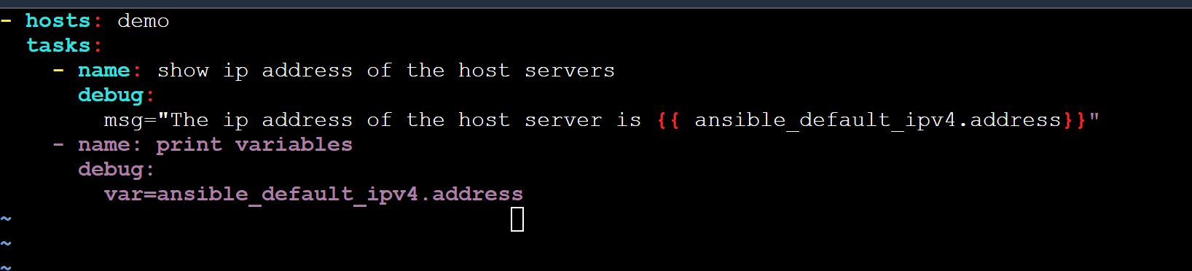

- hosts: demo

tasks:

- name: show ip address of the host servers

debug:

msg="The ip address of the host server is {{ ansible_default_ipv4.address}}"

- name: print variables

debug:

var=ansible_default_ipv4.address